SET partition 1

1. Experiment with the fitness and selection and try to solve the partition problem as well as you can. Try at least two different things.

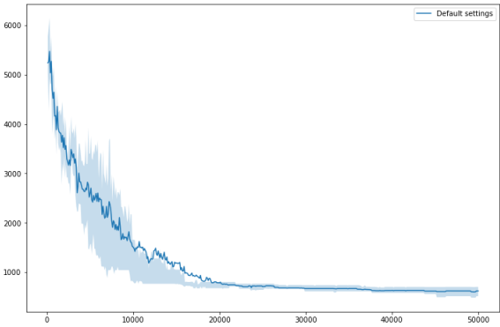

Normal Graph(With Partition_easy.txt)

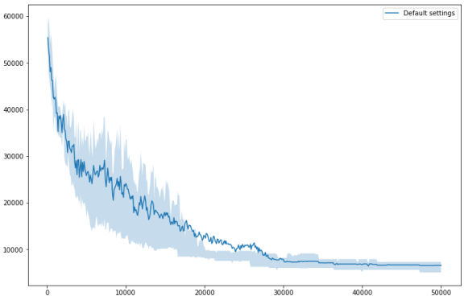

Normal Graph(With Partition_hard.txt)

With Partition_hard.txt

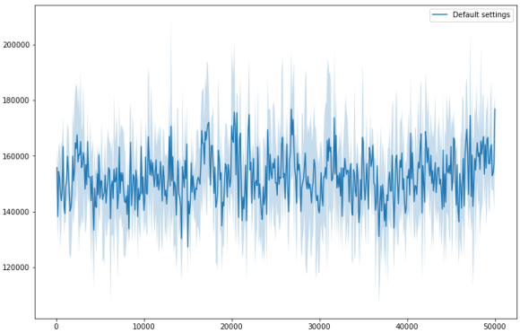

Changing the **fitness** to **(1/(max(bw) + min(bw) +1))**

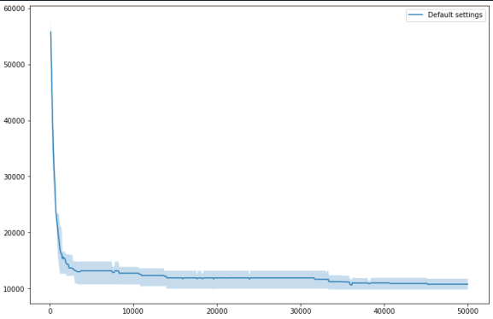

Changing the **fitness=1/(pow(max(bw) - min(bw), 4)**

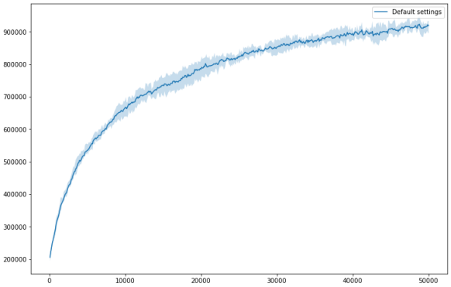

fitness=pow(max(bw) - min(bw), 4)

1. Compare your variants with the basic one in the source codes and submit the plot and a short commentary.

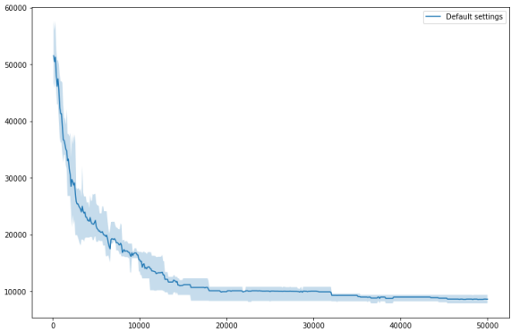 Crossover Probability with 20%.

With Partition_easy.txt

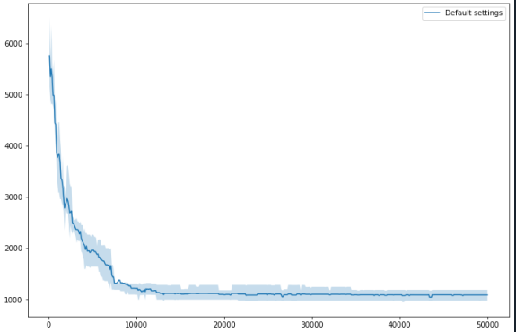

Crossover Probability with 20%.

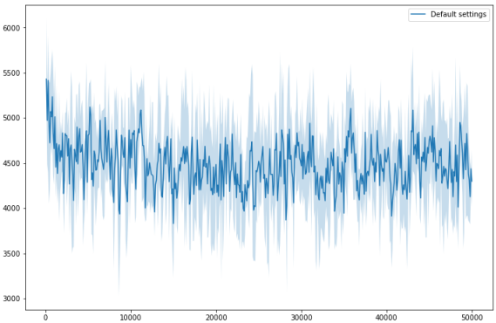

Mutation probability with 50%

1. Put the lowest difference you found directly in the text of the submission and attach the .best with the best solution. I am interested in the one best solution you found, it can be from one lucky run.

With same code from lecture without altering.

Best Least Difference: 344

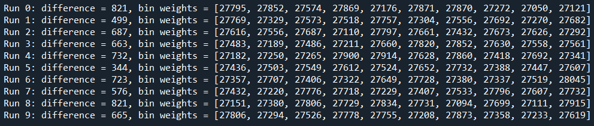

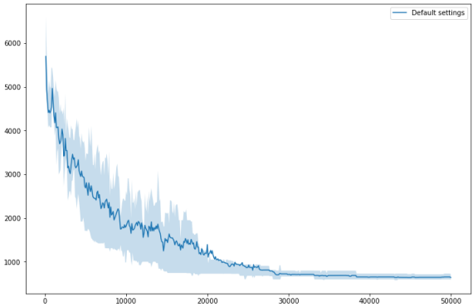

Bonus points - in order to obtain these points, you must not change the genetic operators, you can, however, change all the other settings (selection, population size, probabilities of crossover and mutation, number of generations, fitness function, elite size, …).

+30 points - Find a solution, where the difference between the lightest and heaviest bin is less than 50 (on the easy input).

With Partition_easy.txt

Best Least Difference: 38

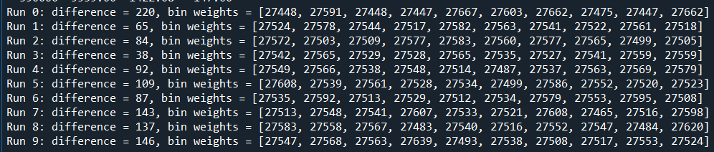

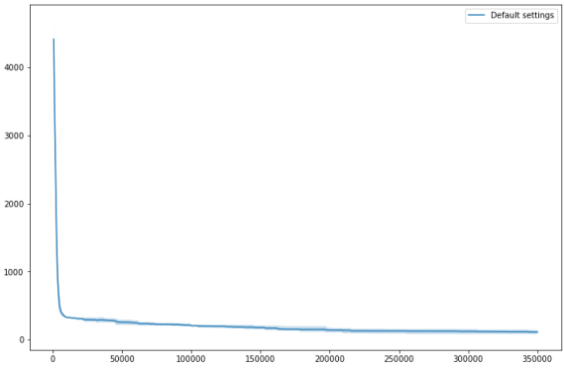

Following changes were made to obtain the result:

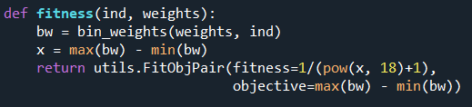

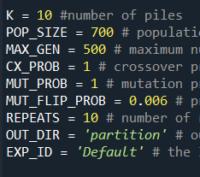

+20 points - Find the optimum solution (difference = 0 on easy input).

Tried, but couldn’t optimize to get 0 difference. ☹